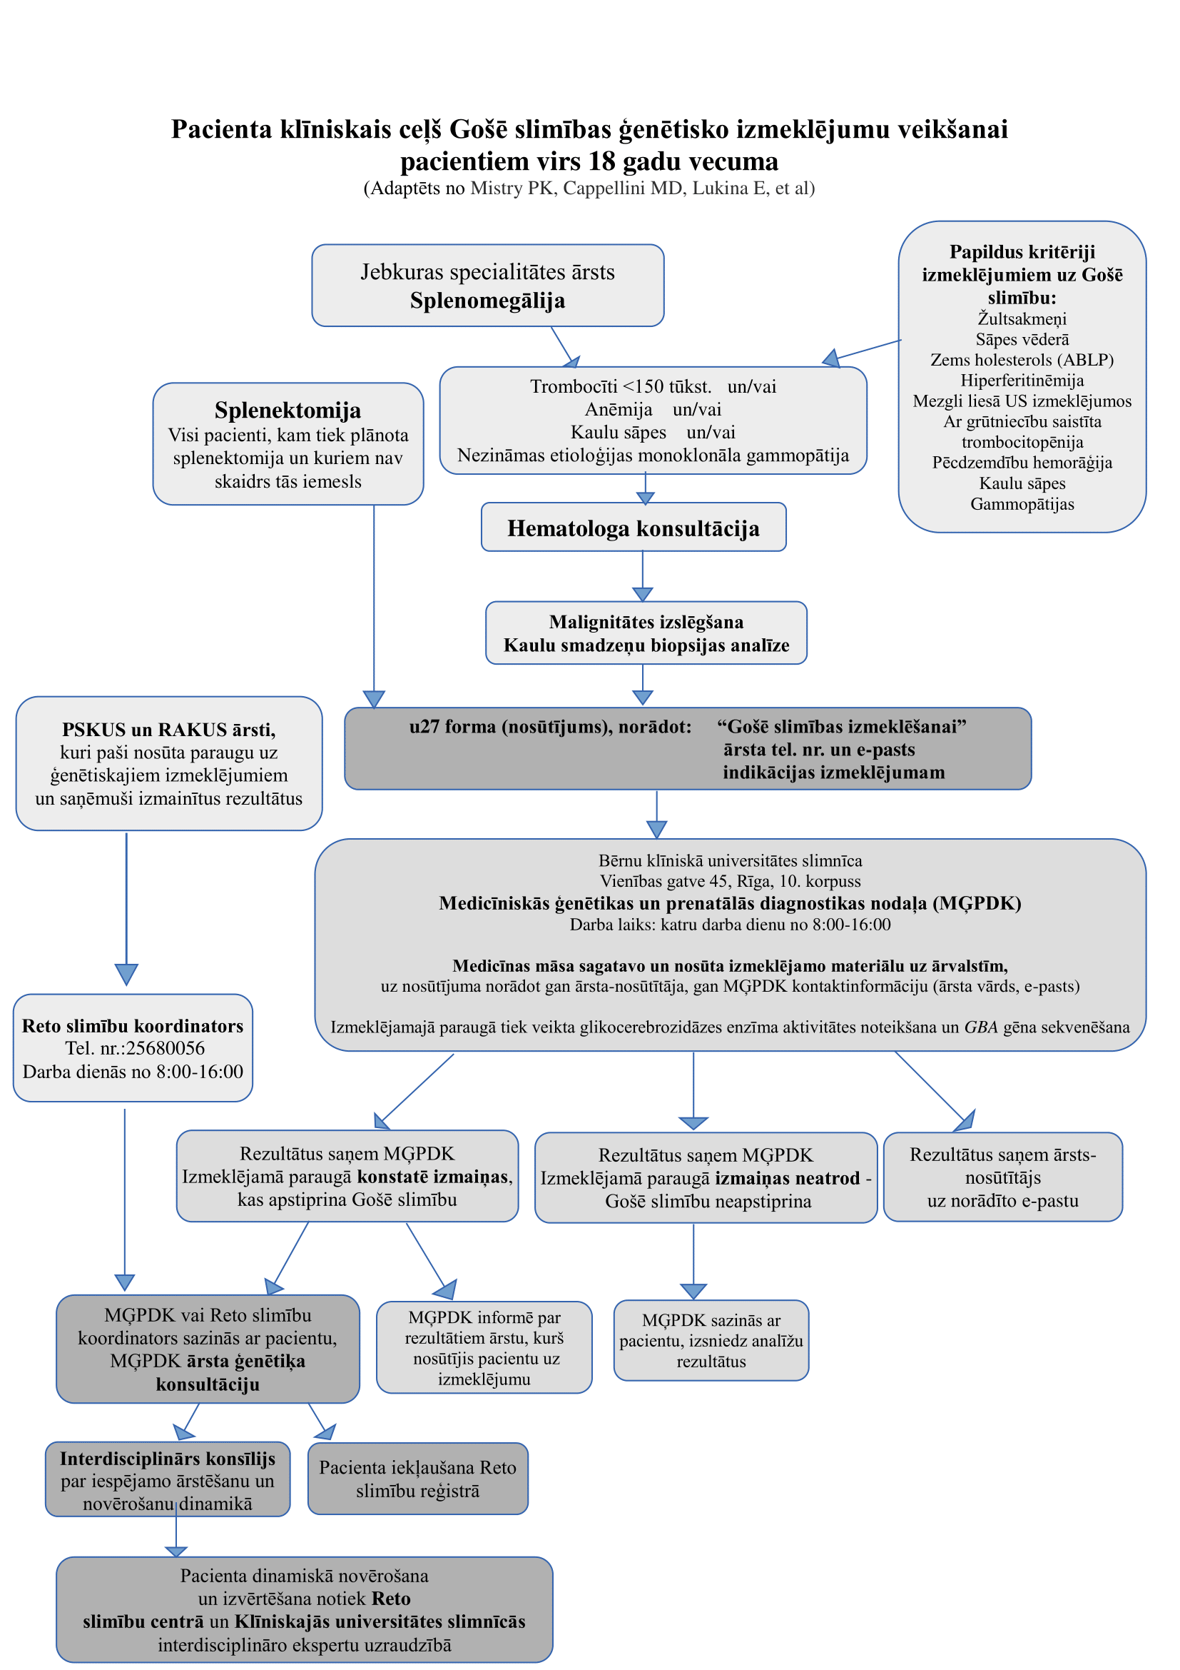
(Adaptēts no Mistry et al., American journal of hematology. 2011;86(1):110-115)

