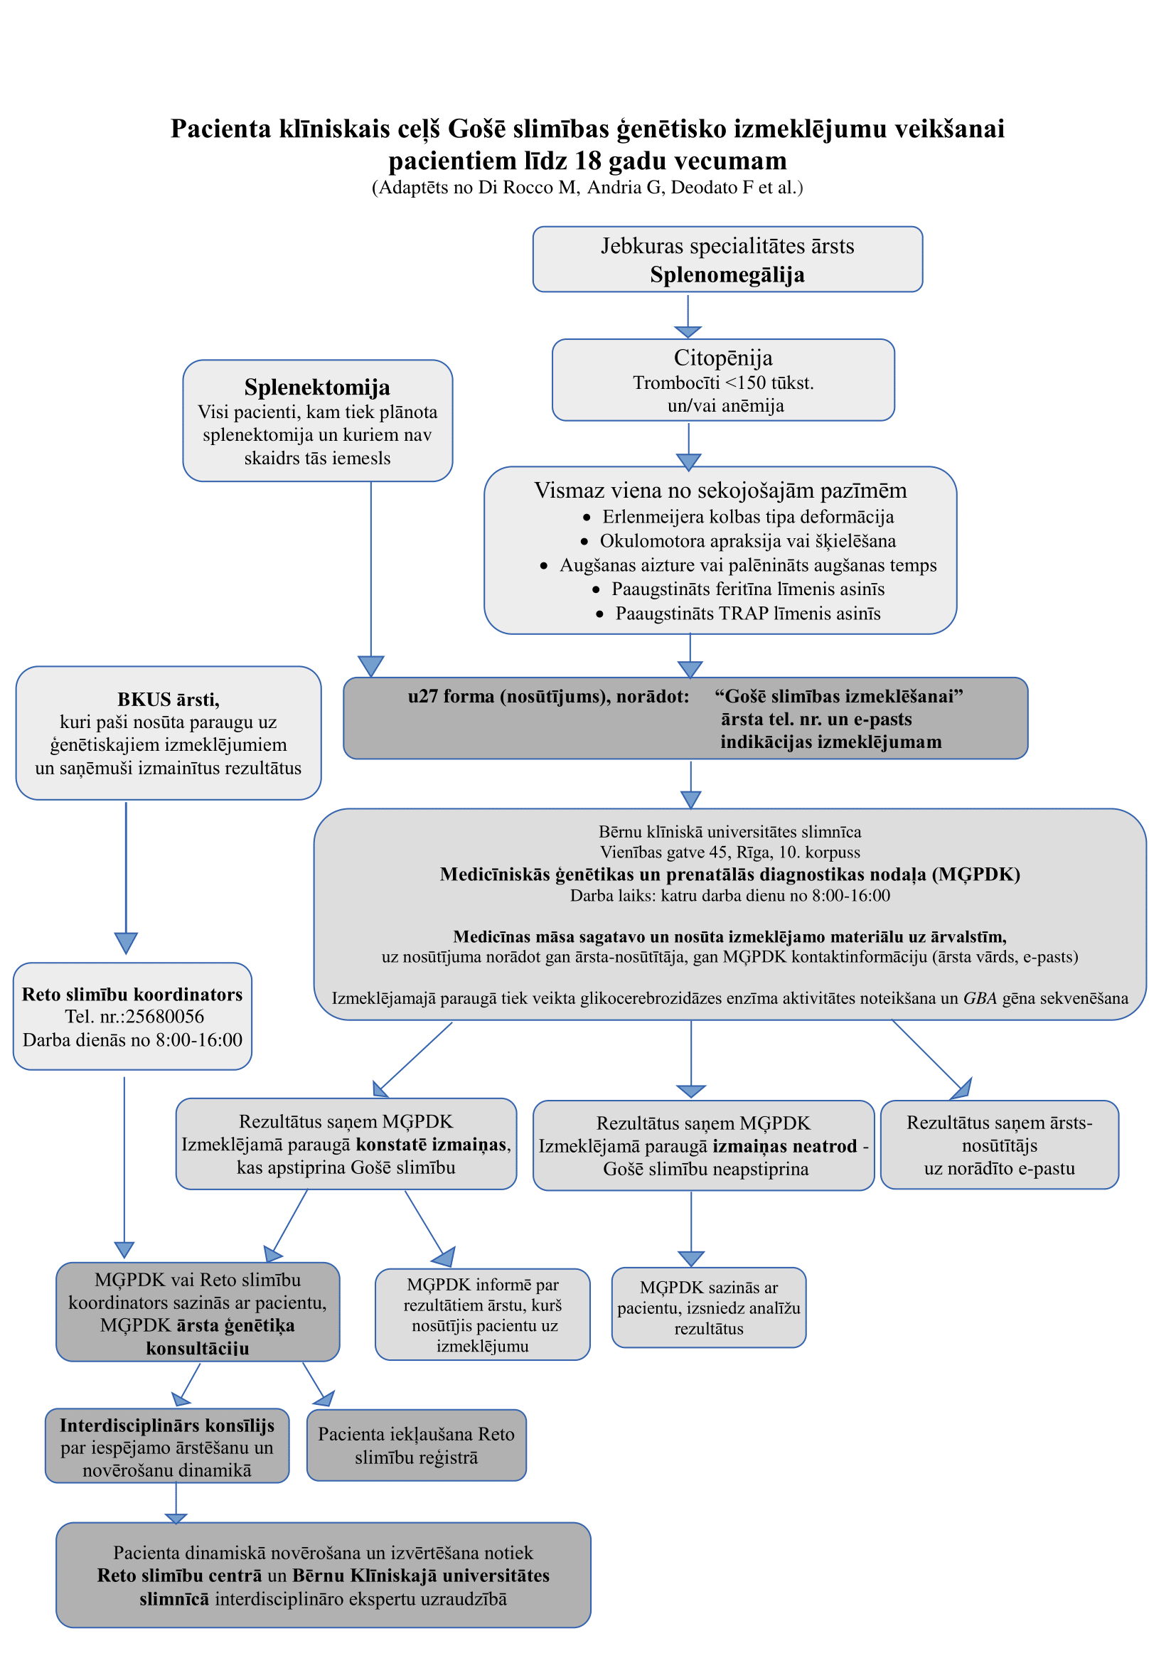
(Adaptēts no Di Rocco M et al., Pediatr Blood Cancer 2014; 61:1905-1909)

