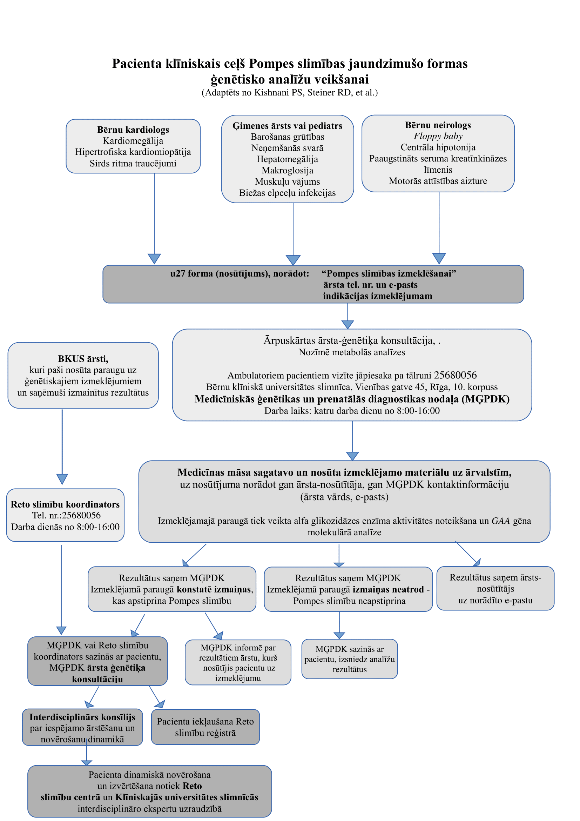
(Adaptēts no Kishnani PS et al., Genetics in Medicine, 2006;8(5):267-288)

