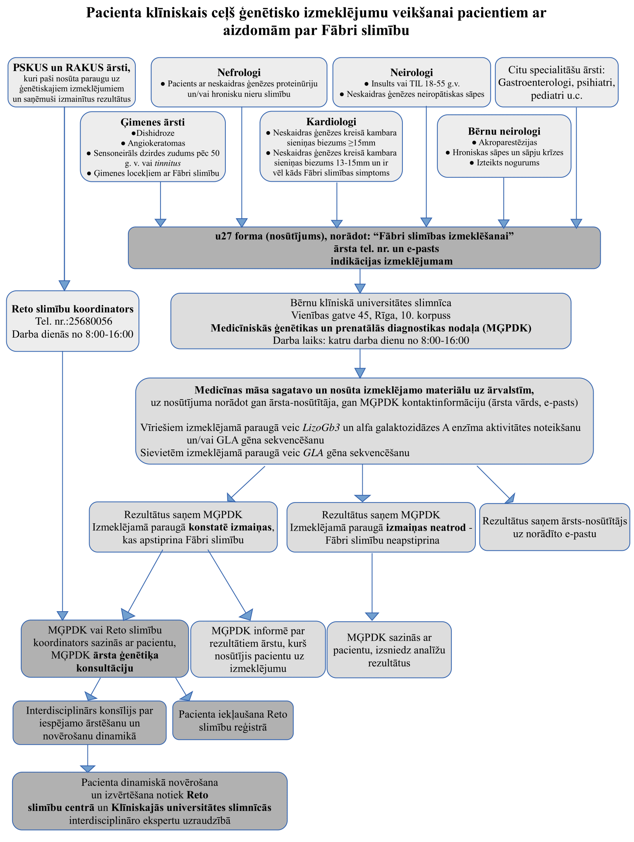
(Materiāla izstrādē izmantots: L. van der Tol, et al., Chronic kidney disease and an uncertain diagnosis of Fabry disease: Approach to a correct diagnosis, Molecular Genetics and Metabolism (Vol. 114, Issue 2, 2015; 242-247))

